1 **Reconstructing the fire history of**

2 **D’urville island, and its ecological**

3 **consequences**

4

5 March 25, 2017

6 **Abstract**

7 Modification of offshore island ecosystems in New Zealand began with the arrival of Polynesians c. 1280

8 AD. European settlement in the early 19th century lead to further transformation. The introduction of

9 regular burning from both waves of settlement has left lasting legacies on New Zealand’s fire-sensitive

10 native vegetation communitites. D’Urville Island has a rich human history in large part because its

11 abundance of metamorphosed indurated mudstone provided an excellent lithic resource for tool building

12 and subsequent trade for Polynesian settlers. We analysed pollen, charcoal and magnetic susceptibility

13 from three different locations, and developed a 2200 year record that begins c. 1550 years before human

14 arrival, and spans c. 650 years of human occupation. The prehuman vegetation on D’Urville Island was a

15 heterogeneous mosaic of Nothofagaceae-Podocarpus forest with a broadleaf sub-canopy and diverse shrub

16 and small tree layer; a ground layer of ferns was also common. Coastal locations and those surrounding

17 lakes and wetlands would have been abundant in Rhopalostylis and Dysoxylum forest. Previous research

18 places human settlement of D’Urville Island at c. 1500 AD (albeit with a substantial potential error

19 range); our study offers a more refined and earlier date of c. 1300 AD. The first wave of Polynesian

20 settlement brought with it transformations to the vegetation assemblages synonymous with previous

21 paleoecological studies throughout New Zealand. Fire was a major contributor to this transformation and

22 charcoal is common in the record during both Polynesian and European settlement waves. With European

23 settlement a decline in charcoal accumulation occurs, but there is no recovery of native forest. During

24 this European period, exotic plant species appear and subsequently spread across the landscape. Despite

25 suffering widespead desforestion, typical with much of the New Zealand mainland and offshore islands,

26 D’Urville Island posses many areas worthy of conservation, given the number of threatened mistoloe,

27 ultramafic communities and regionally rare species.

1

28 I. Introduction

29 Anthropic changes to fire regimes have resulted in drastic and rapid shifts in ecosystem function,

30 structure and composition, especially in locations whose ecosystems are ill-adapted to frequent

31 fire (McWethy et al., 2013). New Zealand has been no exception. In comparison to a number of its

32 Gondwanan neighbours, New Zealand’s vegetation shows little evidence of adaptation to frequent

33 fire, presumably as a result of the very low fire frequencies prior to human settlement. Infrequent

34 fire, combined with New Zealand’s maritime climate prompted Ogden et al. (1998) to suggest the

35 pre-human frequency of fires had the potential to be millennial in some sites. Perry et al. (2014)

36 argue that the charcoal analysis used to decipher fire frequencies is highly biased towards the

37 east coast of the South Island, making it somewhat difficult to derive conclusions that encompass

38 all of New Zealand. It is likely that some ecosystems experienced fire more often than others.

39 For example, the combination of physical conditions and vegetation type in wetlands make them

40 relatively more fire prone (McGlone, 1983, 2009, Perry et al., 2014). Evidence from the eastern

41 North Island suggests increasing fire activity from the mid-Holocene onwards (Horrocks et al.,

42 2001, Rogers et al., 2007), possibly as a result of increasing droughts from the greater intensity and

43 frequency of El Niño-Southern Oscillation (ENSO) events (McGlone et al., 1992, Perry et al., 2014).

44 Regardless of the precise fire frequencies throughout both the North and South Islands, the

45 evidence overwhelmingly suggests that most of New Zealand’s indigenous woody vegetation

46 was not adapted to frequent fire (Wilmshurst & McGlone, 1996). New Zealand ’s tree species are

47 characterised by seeds vulnerable to fire and lack the fire-stimulated re-sprouting capabilities of

48 species in ecosystems where fire is more common (Perry et al., 2014). New Zealand’s tree species

49 also lack the traits fire-prone systems exhibit, such as thick bark capable of protecting cambium

50 from lethal temperatures experienced during fires (Richardson et al., 2015). This lack of fire-

51 adapted vegetation, and extended period of recovery, contributed to the rapid elimination of New

52 Zealand forest upon human arrival (McGlone, 1983). Indeed the significant increase in bracken

53 spores (Pteridium esculentum) and abundance of charcoal towards the late Holocene, coinciding with

54 the decline in forest pollen taxa, indicates increased fire frequency that accompanied Polynesian

55 arrival (McGlone & Wilmshurst, 1999). A synthesis of charcoal records from 16 lakes across the

56 South Island suggests that forest decline was both rapid and severe, reducing forest cover from

57 85-90%, to as little as 40% within 100 years (McWethy et al., 2009, 2014).

58 To date most ecologically-oriented fire history research in New Zealand has focused on trying

59 to understand the process and pattern of initial deforestation by human-lit fires immediately

60 following Polynesian settlement in the 13th century (McGlone & Wilmshurst, 1999, McGlone et al.,

61 2005, McWethy et al., 2009, Perry et al., 2012, Wilmshurst et al., 2004, Wilmshurst & McGlone,

62 1996). Thus, a significant component of New Zealand’s fire story remains largely untold. European

63 settlers rapidly changed the landscape. Slash and burn techniques were used to convert native

64 bush into agriculture; however, the difficulties of controlling such fires often led to large areas of

65 land burning unintentionally (Pawson & Brooking, 2002). Landholders were, by law, required

66 to improve their land and to many the most efficient way to achieve this was by burning forest

67 (Salmon, 1975). The combined result of both those Polynesian and European fire and deforestation

68 footprints was a reduction of native forest to just 23% of the land surface area (Ewers et al., 2006).

69 Paleoecologists have largely ignored this recent period (150 years or so) of fire in New Zealand, but

70 it has been responsible for creating alternative stable states in some areas. The exotic flammable

71 species that arrived with Europeans (e.g. Pinus spp., Ulex spp., Hakea spp.) have helped create

72 interesting fire-vegetation feedbacks (Perry et al., 2014). These feedbacks, alongside declines in

73 dispersal and pollination services (Keeley et al., 2011, Kitzberger et al., 2016), and the introduction

74 of seed and seedling predators (Perry et al., 2015, Sullivan et al., 2010) have potentially driven

75 landscapes into 'traps' from which escape is difficult in the absence of intensive restoration and

76 conservation. Despite these vegetation assemblages being prominent in many parts of the North

77 and South Island, we know little of the fire regimes that caused them to emerge.

78 Although the frequency of fire in New Zealand has declined in the late 20th century (Anderson

79 et al., 2008, Perry et al., 2014), climate change may further complicate restoration efforts (Harris

80 et al., 2006, McGlone & Walker, 2011, Zavaleta & Heller, 2009) and potentially heighten the risk

81 of fire in some of the altered vegetation states we witness in areas where fire is a relatively

82 new disturbance mechanism. Better understanding of historic fire-related drivers of vegetation

83 change will increase our fundamental knowledge of New Zealand’s fire history and inform

84 decisions when applying restoration baselines and conservation efforts in modern landscapes.

85 We used high-resolution pollen and charcoal reconstructions from a partially forested island in

86 southern New Zealand to determine pre-human vegetation baselines and fire frequency. From

87 these reconstructions we estimate Polynesian arrival and discuss the role human settlement had

88 in shaping the modern vegetation assemblages now witnessed . We discuss the implications of

89 such altered plant communities, while also considering the valuable conservation opportunities

90 available.

91 II. Study site

92

93

94

95

96

97

98

99

100

101

102

103

104

105

D’Urville Island, Rangitoto ke te Tonga, sits at the north-western entrance to the Marlborough Sounds, South Island, New Zealand (40◦ 500 S 173◦ 520 E). At 150 km2 it is New Zealand’s eighth largest island. The coastline is typical of those throughout the Marlborough sounds, and its convoluted form results from river valleys that were drowned during the post-glacial rise in sea level (Wellman, 1962). Topographically the island incorporates a range of features including headlands, strong ridges, confined flats, inlets, steep hills and cliff systems. A series of islets and rock stacks surround the island, along with several coastal lagoons (Wellman, 1962). The highest point sits at 728 m (Attempt Hill) and is located close to the island’s center (Fig: 1).

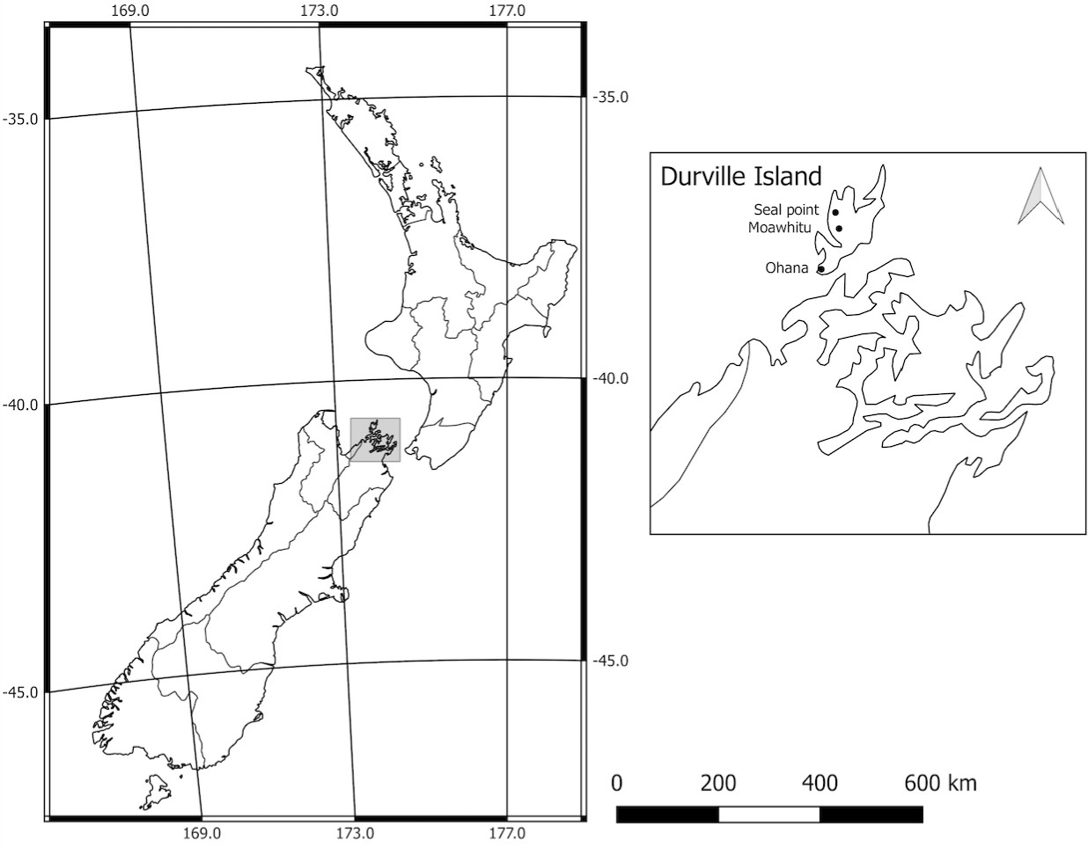

**Figure 1:** Location of study sites (black circles), New Zealand

D’Urville’s climate is maritime and consists of prevailing north-west winds, reliable rainfall, frequent gales, mild winters and warm summers (Walls, 2009). Temperatures during the summer months of January to March reach an average daily maximum of 24◦ C and are among the warmest in the South Island of New Zealand. Typical winter daytime temperatures are in the range 10◦ C -

15◦ C. Drought-like conditions are sometimes experienced within the region. On average, D’Urville

Island receives over 1000mm of rain annually (NIWA, 2017).

106

107

108

109

110

111

112

113

The island’s geology is comprised of igneous conglomerate, Permian argillite and widespread areas of mafic and ultramafic rocks, collectively known as the 'Mineral Belt' (Walls, 2009) or the

'Dun Mountain Ophiolite Belt' (Lee, 1992). As a result, the soils in parts of the island contain high concentrations of heavy metals such as iron, copper, magnesium and nickel. Thus, it is a component of the small (0.4%) part of the NZ landmass that can be described as 'serpentine' (Lee, 1992). The ultramafic areas create an environment difficult for most plant species, and are characterised by unique plant communities able to tolerate the high concentration of metallic

minerals in the soil.

114

115

116

117

118

119

120

121

122

123

124

125

126

127

128

D’Urville Island was an important cultural setting for early Polynesians. Argillites strength and ability to hold a sharpened edge made it ideal for making weapons and tools. Adzes, a tool dating back to the Stone Age, commonly used to smooth or carve wood, were a key instrument used for trade. Flakes of argillite dominate the occupation layers in the cores analysed by Wellman (1962), leading him to estimate a total of 60 tonnes was extracted during the island’s Polynesian occupation, or enough to manufacture not less than 15,000 adzes, acknowledging this is likely an underestimate due to the amount of flakes still hidden. Lithic exchange was extremely important to Polynesian settlers, and we see argillites from the northern South Island appearing in the Bay of Plenty (central eastern New Zealand) less than 10 years after quarries appearing on the landscape (Walter et al., 2010). The evidence suggests that D’Urville was the centre of flourishing trade given the inferior quality of rock in other parts of New Zealand. Midden deposits are found in every bay on D’Urville Island, as are stone walls associated with gardens (Walls, 2009). The occupation layer examined by Wellman (1962) provides evidence that horticulture was likely to have been prominent on the sandy flats, as shown by the uniform distribution of pebbles associated with

growing ku¯ mara (pomoea spp).

129

130

131

132

133

134

135

136

137

138

The following vegetation descriptions have been summarised with permission from Walls (2005,

2009); other descriptions also appear in Lee (1992) and Beever et al. (1989). As with much of New Zealand, human arrival on D’Urville Island brought about a significant loss of native forest, and what remains can be best described as a complex mosaic of exotic plantations, forest remnants, pasture and areas undergoing secondary succession following clearing. The most accessible and fertile low areas have, unsurprisingly, been converted into grazed pasture, yet areas of fernland and shrub have survived in the areas not suited to farming. The expansion of fern and shrubland into previously grazed regions due to a cessation of farming is noticeable in several areas and these are, predictably, dominated by the early successional species such as Kunzea spp., Leptospermum scoparium, bracken (Pteridium esculentum), Cyathea medullaris, Coprosma robusta, Melicytus ramiflorus

139

140

141

142

143

144

145

146

147

148

149

150

151

152

153

154

155

156

and Cordyline australis. Fuscospora truncata dominates on many of the ridges and slopes from 500 m above sea level (asl) to sea-level, often in association with Fuscospora solandri, Dacrydium cupressinum and Elaeocarpus dentatus. At higher elevation, and in the cooler, moister areas, Fuscospora truncata is replaced by Lophozonia menziesii, Lophozonia fusca, Prumnopitys ferruginea, Metrosideros umbellata and other broadleaf species. Coastal flats and some coastal slopes, along with gullies, contain many of the broadleaf species abundant throughout of the North Island of New Zealand; of these species, Dysoxylum spectabile is most abundant, but Rhopalostylis sapida, Laurelia novae-zelandiae, Beilschmiedia tawa, Alectryon excelsus, Piper excelsum, Aristotelia serrata, Hedycarya arborea, Cyathea spp. and Carpodetus serratus are common. Small examples of the low-forest climax vegetation on ultramafic areas still exist, but are limited to higher elevations and consist of Fuscospora truncata, Dacrydium cupressinum, Metrosideros umbellata, Pseudopanax crassifolius and Leptospermum scoparium. Although the ultramafic soils exclude many common woody weeds found in the region, wilding pines such as Pinus contorta and Pseudotsuga menziesii are invading some locations. D’Urville Islands possum-free (Trichosurus vulpecula) status has also allowed for an abundance of mistletoe to adorn the island; also present are examples of endangered species such as Anemanthele lessoniana and Euphorbia glauca. Mammalian pests associated with much of New Zealand exist on D’Urville Island and include feral pigs (Sus scrofa), rodents, hedgehogs (Erinaceus europaeus occidentalis) and

mustelids (Walls, 2009).

157

III. Methods

158

159

160

A D-section hand corer was used to collect a 250 cm long soil core from Moawhitu Swamp. Cores from the lakes at Seal Point (143 cm length) and Ohana (136 cm length) were collected using a

simple gravity lake corer.

161

i. Pollen Analysis

162

163

164

165

166

167

We subsampled 2 mL of soil from the Moawhitu Swamp core every 4 cm for pollen analysis. Standard preparation techniques were used to make microscope slides suitable for palynological analysis (Moore et al., 1991). On each slide pollen from trees, shrubs, herbs and bracken spores were recorded until a total of 250 grains was reached. Reference collections (Landcare Research) and atlases (e.g. Moar, 1993) were used to identify pollen to the highest possible taxonomic resolution. Distinct and unprecedented changes in vegetation and charcoal inputs were used

168

169

to isolate initial human activity. Pollen and charcoal diagrams were constructed using the C2

software package (Juggins, 2007)

170

ii. Charcoal Analysis

171

172

173

174

175

176

177

178

179

180

181

Charcoal was examined at high-resolution as per Whitlock & Larsen (2002) to reconstruct local fire activity. Samples from Moawhitu Swamp, Seal Point and Ohana cores were taken at contiguous

1 cm intervals using a brass sampler with a rectangular cutting edge. Sub-samples were taken at a volume of 2 cm3 where sufficient material was available, and 1 cm3 if not in the Moawhitu Swamp core. At both Seal Point and Ohana sub-samples were taken at a volume of 5 cm3 . All samples were soaked in 6% bleach for 24 hours. At Moawhitu Swamp samples were washed through Petri dishes 250 µm, 125 µm and 63 µm, at Seal Point and Ohana samples were washed through 125 µm Petri dishes. Charcoal particles were counted using a stereomicroscope at 50-100x magnification. Charcoal concentration (number of particles/cm3 ) was determined using total charcoal counts divided by the volume of sediment sieved. Charcoal accumulation rates were

calculated by dividing charcoal concentration by deposition time (yr/cm) between each sample.

182

iii. Radiocarbon dating

183

184

185

186

187

188

189

190

191

We submitted three twig samples from the Moawhitu Swamp core to the Waiakto Radiocarbon Dating Laboratory, New Zealand for accelerator mass spectrometry (AMS) radiocarbon dating. Ages of all dated material are expressed as calibrated 14 C age before present (cal. year BP). The samples from Moawhitu Swamp were taken from 32 cm, 59 cm and 94 cm. Three cal. year BP dates were supplied from Ohana at 94 cm, 103 cm and 122 cm, and three from Seal Point at 80 cm,

105 cm and 115 cm. These dates are courtesy of Dr. David McWethy, Montanta State University, USA. Age-depth modelling, as per the algorithm of (Haslett & Parnell, 2008) and the Southern Hemisphere (SHCal13) calibration curve (Hogg et al., 2013), were constructed using the Bchron package (Parnell, 2014) in the R statistical suite (R Core Team, 2015) version 3.1.3 (Fig: 2).

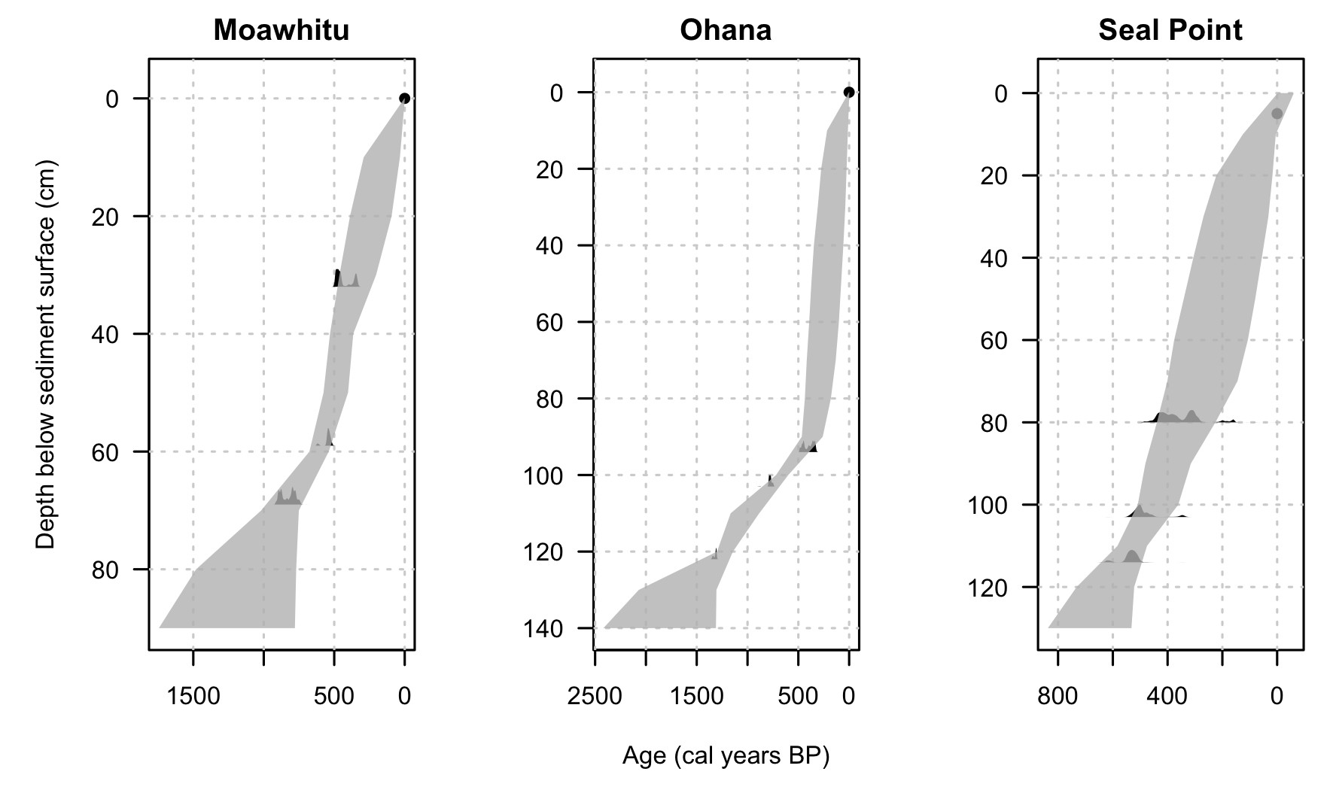

**Figure 2:** Age depth models for each site constructed using the compound Poisson-Gamma chronology model of Haslett

& Parnell (2008). Light grey distributions indicate probability distributions from calibrated 14 C dates.

192

iv. Statistical analysis

193

194

195

196

197

198

199

200

Statistical analysis was conducted using the R statistical package (R Core Team, 2015), version

3.2.3. Constrained cluster analysis that honoured the location of sites (CONISS), and nMDS ordination, using the Bray-Curtis measure (Faith et al., 1987) were performed on the pollen reconstruction from Moawhitu Swamp using the rioja (Juggins, 2015) and VEGAN (Dixon & Palmer, 2003) packages. Permutational multivariate analysis of variance (PERMANOVA) using distance matrices (Anderson, 2001) were performed using the adonis command to statistically evaluate the dissimilarity between settlement and prehuman zones. Temporal auto-correlation between charcoal and magnetic susceptibility was conducted using the acf and ccf functions.

201

v. Magnetic Susceptibility

202

Not sure of the methods here.... Only for Seal Point and Ohana

203

IV. Results

204

205

206

207

208

209

210

211

The timing of human arrival was estimated using a combination of distinct changes in pollen taxa (e.g. the introduction of exotic species), charcoal reconstructions and accompanied by statistical analysis of the pollen reconstruction from Moawhitu Swamp. Three zones were initially identified as a result of nMDS ordination on pollen taxa from the Moawhitu Swamp core: Zone 3 (0-20 cm,

0-125 cal. years BP), zone 2 (20-64 cm, 150-650 cal. years BP) and zone 1 (64-250 cm, 650-2200 cal. years BP) (Fig: 3). Vegetation changes are demonstrated by a rapid rise in bracken and Poaceae, accompanied by a decrease in native forest taxa (Fig: 4, 5, 6), and the increase of charcoal into the Moawhitu Swamp, Seal Point and Ohana cores (Fig: 4, 7, 8).

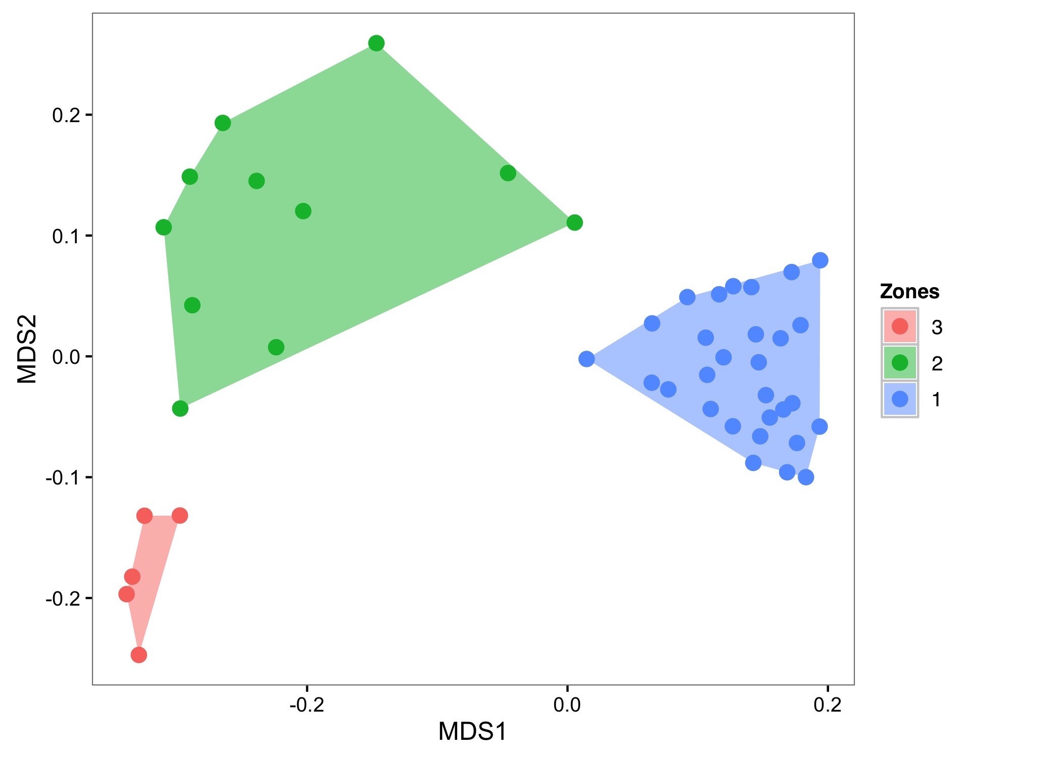

**Figure 3:** nMDS Ordination of settlement and prehuman zones identified from cluster analysis. Zones identified by different colors. Stress level = 0.1. Polygons indicate minimum bounding box.

212

i. Zone 1 - 650 - 2120 cal. years BP

213

214

215

216

217

218

Based on the pollen present, zone 1 comprises a Nothofagaceae-Podocarpus mosaic with a broadleaf sub-canopy and a ground layer of ferns (Fig: 4, 5). Also notable is the presence of Rhopalostylis sapida and Dysoxylum spectabile, which is indicative of a rich coastal, lake and wetland forest. There are no discernible shifts in vegetation during this part of the core and pollen sum percentages remain relatively consistent. The podocarp taxa are the most variable component of the palynoflora

(Fig: 4).

219

ii. Zone 2 - 150 - 650 cal. years BP

220

221

222

223

224

225

The decline in podocarps as forest was cleared is an indication of change in zone 2 from zone 1 (Fig: 4, 6). The biggest drivers of this difference are the decrease in podocarps, and increase in grasses and bracken, as forest taxa are replaced by disturbance-tolerant species. The creation of young and seral forest is evident in the increase in Leptospermum scoparium and Cordyline pollen (Fig: 4, 6). Large fire events during this period are evidenced by spikes in bracken, Typha and

monolete fern spores.

226

iii. Zone 3 - 0 -150 cal. years BP

227

228

229

230

231

232

233

234

235

The arrival or establishment of several exotic species, including Taraxacum spp., Pinus spp., and the non-native Plantago, marks zone 3. Pollen of disturbance-related taxa such as bracken, Typha spp., and monolete fern spores contribute most to the differences observed. Monolete fern spores and Typha decline during this modern period and this is likely due to the reduction in fire-related disturbance events (Fig: 4, 6). Exotics, such as Pinus and non-native Plantago, are also important contributors to the different vegetation communities observed. Forest taxa, particularly podocarps, have the lowest pollen sum percentage observed across all three zones. The open forest favours the growth of light-demanding and pioneer species such as Leptospermum scoparium, Kunzea spp. and Cordyline.

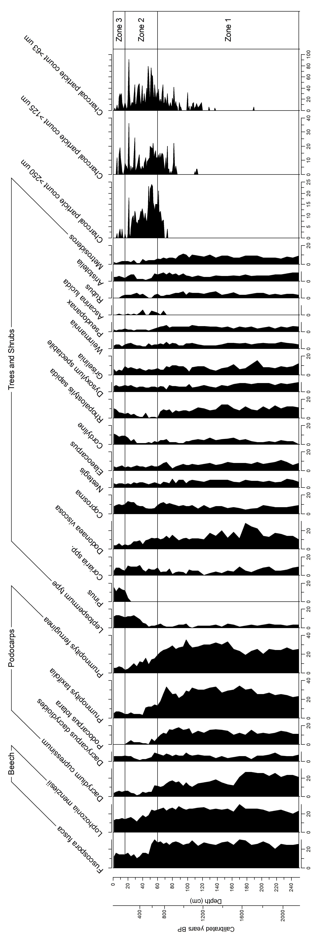

**Figure 4:** Nothofagaceae, Podocarpaceae and small trees and shrubs pollen identified at Moawhitu Swamp. Pollen sum given as a percentage of total pollen count.

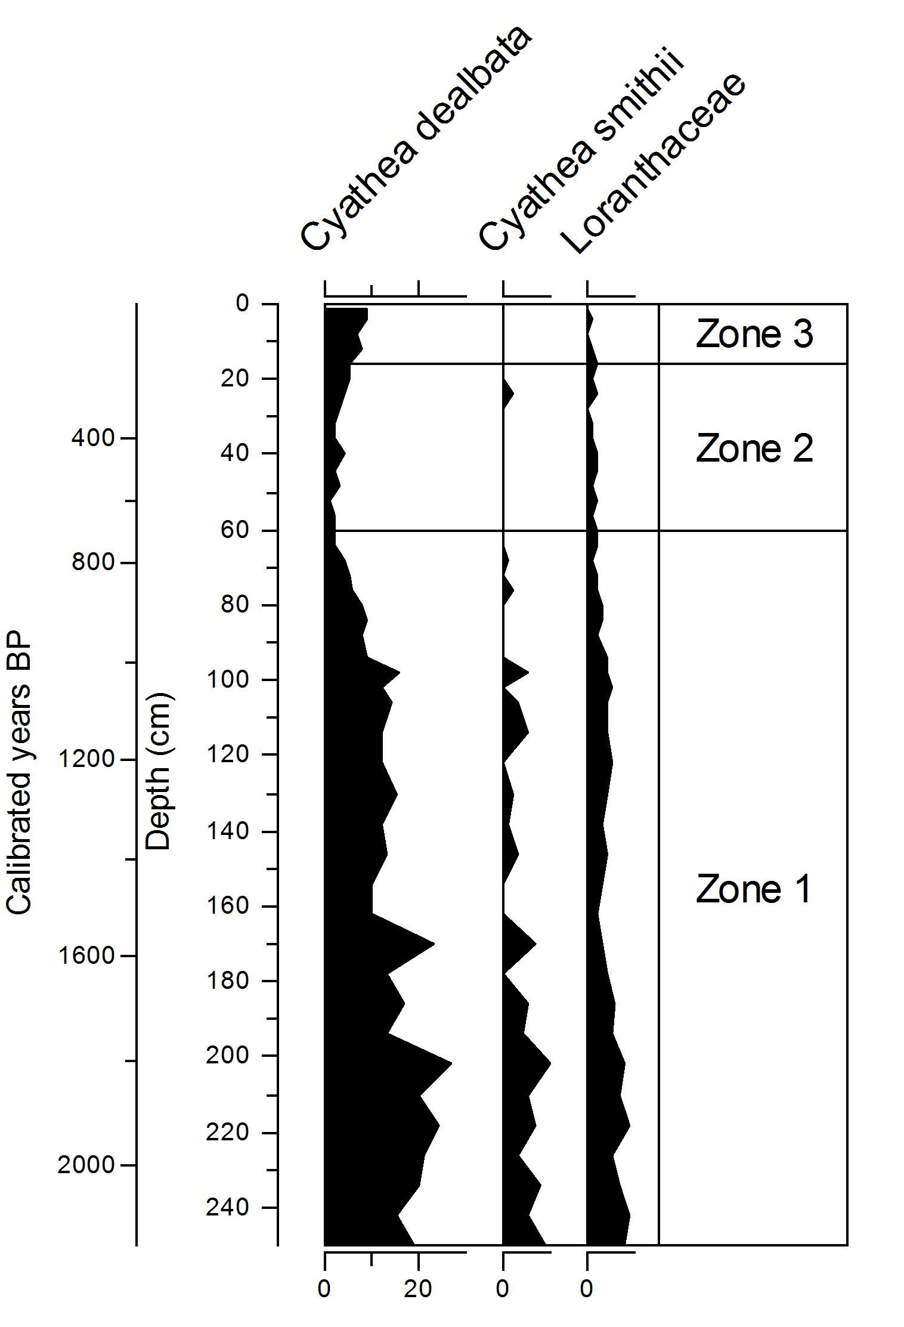

**Figure 5:** Ferns and mistletoe identified in the pollen reconstruction from Moawhitu Swamp. Pollen sum given as a percentage of total pollen count.

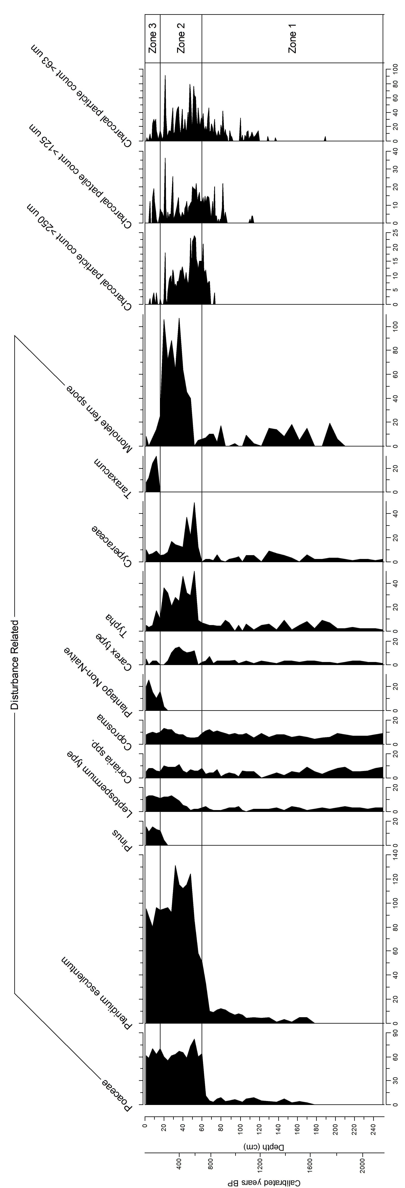

**Figure 6:** Changes in species associated with disturbance in pollen reconstruction from Moawhitu Swamp.

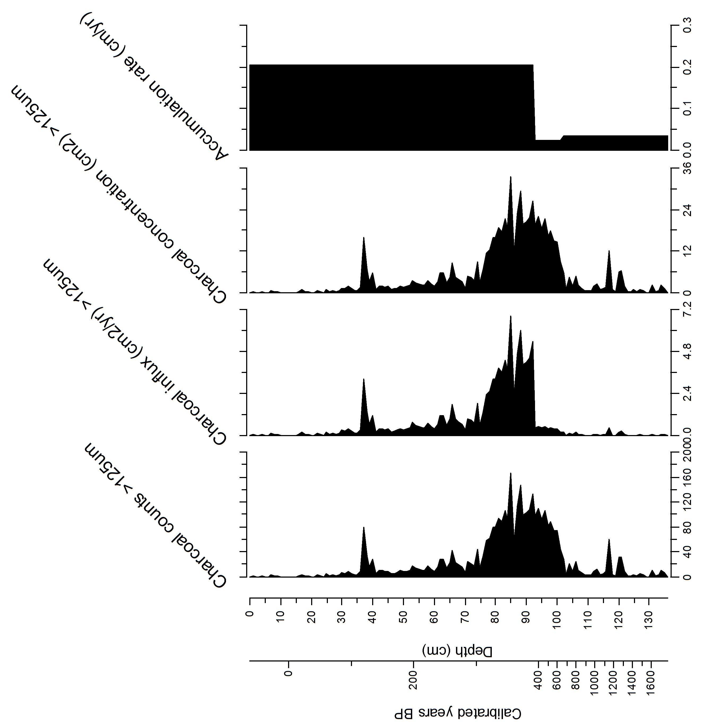

**Figure 7:** Macroscopic charcoal from the Ohana profile, expressed as concentrations and influx. Sedimentation rates

expressed as accumulation (cm/yr).

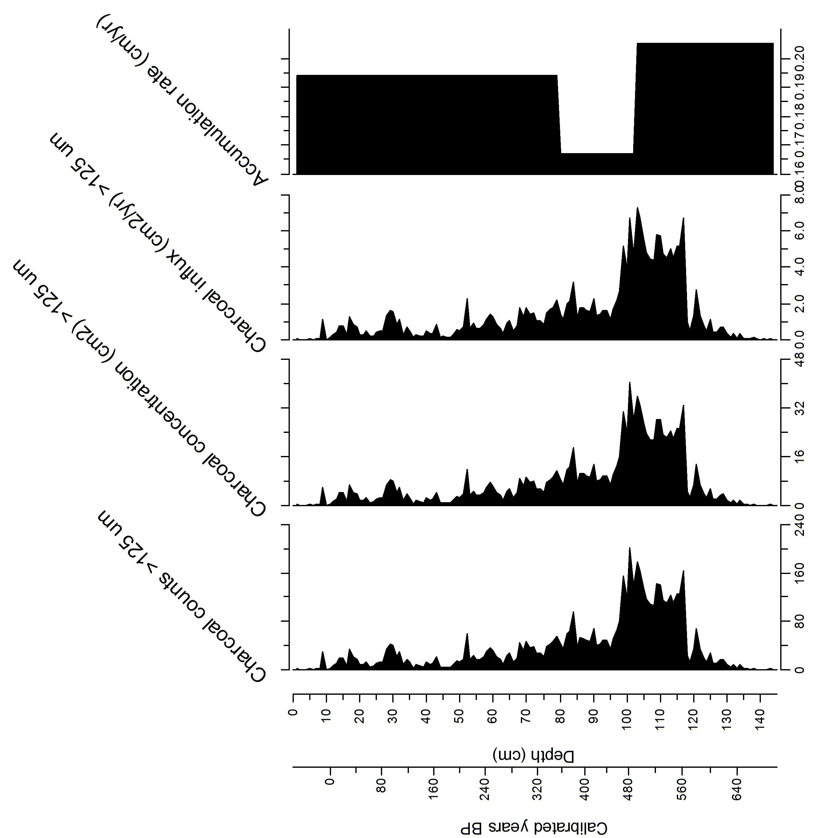

**Figure 8:** Macroscopic charcoal from the Seal Point profile, expressed as concentrations and influx. Sedimentation rates expressed as accumulation (cm/yr).

236

iv. Sediment-charcoal records

237

238

239

240

241

242

243

244

245

246

247

248

Charcoal is absent from much of zone 1 in the Moawhitu Swamp core (Fig: 4). Consistent inputs of microscopic charcoal at Moawhitu Swamp begin around 1100 cal. years BP, with three peaks at c. 490, 470 and 228 cal. years BP. All three sites show increasing macroscopic charcoal inputs from around 650 cal. years BP onwards, with charcoal concentrations being highest from 400

- 600 cal. years BP (Fig: 4, 7, 8). The Ohana Lake profile also exhibits another charcoal peak at 120 cal. years BP after a steady decline, with Seal Point also showing higher concentrations around this period (Fig: 7, 8). The Moawhitu Swamp core is more temporally variable in terms of charcoal concentration, but shows a similar pattern of increased burning at around 100 cal. years BP (Fig: 4). A visual comparison of charcoal concentration and influx from the Moawhitu and Seal Point cores reveals close agreement in temporal pattern across size classes (Fig: 4, 8). A dramatic increase in accumulation after nearly three centuries of increased charcoal inputs correlates with

increases in charcoal influx just after 400 cal. years BP in the Ohana core (Fig: 7).

249

v. Magnetic susceptibility

250

251

252

253

254

255

256

257

258

259

260

261

262

263

Corresponding with Polynesian arrival, magnetic susceptibility increases from c. 600 cal. years BP in the Seal Point core. This rise in magnetic susceptibility peaks c. 175 years later, and then shows a fluctuating decline until European arrival (c. 150 cal. year BP), when magnetic susceptibility increases until a peak c. 120 cal. years BP, gradually declining thereafter. Polynesian settlement does not give a clear signal in the Ohana core, with magnetic susceptibility declining c. 600 cal. years BP. This decline continues for c. 200 years before we see increases to the highest magnetic susceptibility levels seen in the core. European settlement provides a clearer signal in the Ohana core, with similar magnetic susceptibility increases c. 150 cal. years BP to those in Seal Point. Charcoal and magnetic susceptibility were not significantly correlated in either the Seal Point or Ohana profiles, (r=0.179 and r=0.157, respectively), however there is a significant lagged correlation between fire activity (as measured by charcoal) and magnetic susceptibility. The maximum correlation occurs when a lag of 22 cm is applied (r=0.541, P <0.05) or approximately

60 years to the Seal Point core. Correlation also improves (r=0.547, P <0.05) when a 50 year lag is applied to the Ohana profile.

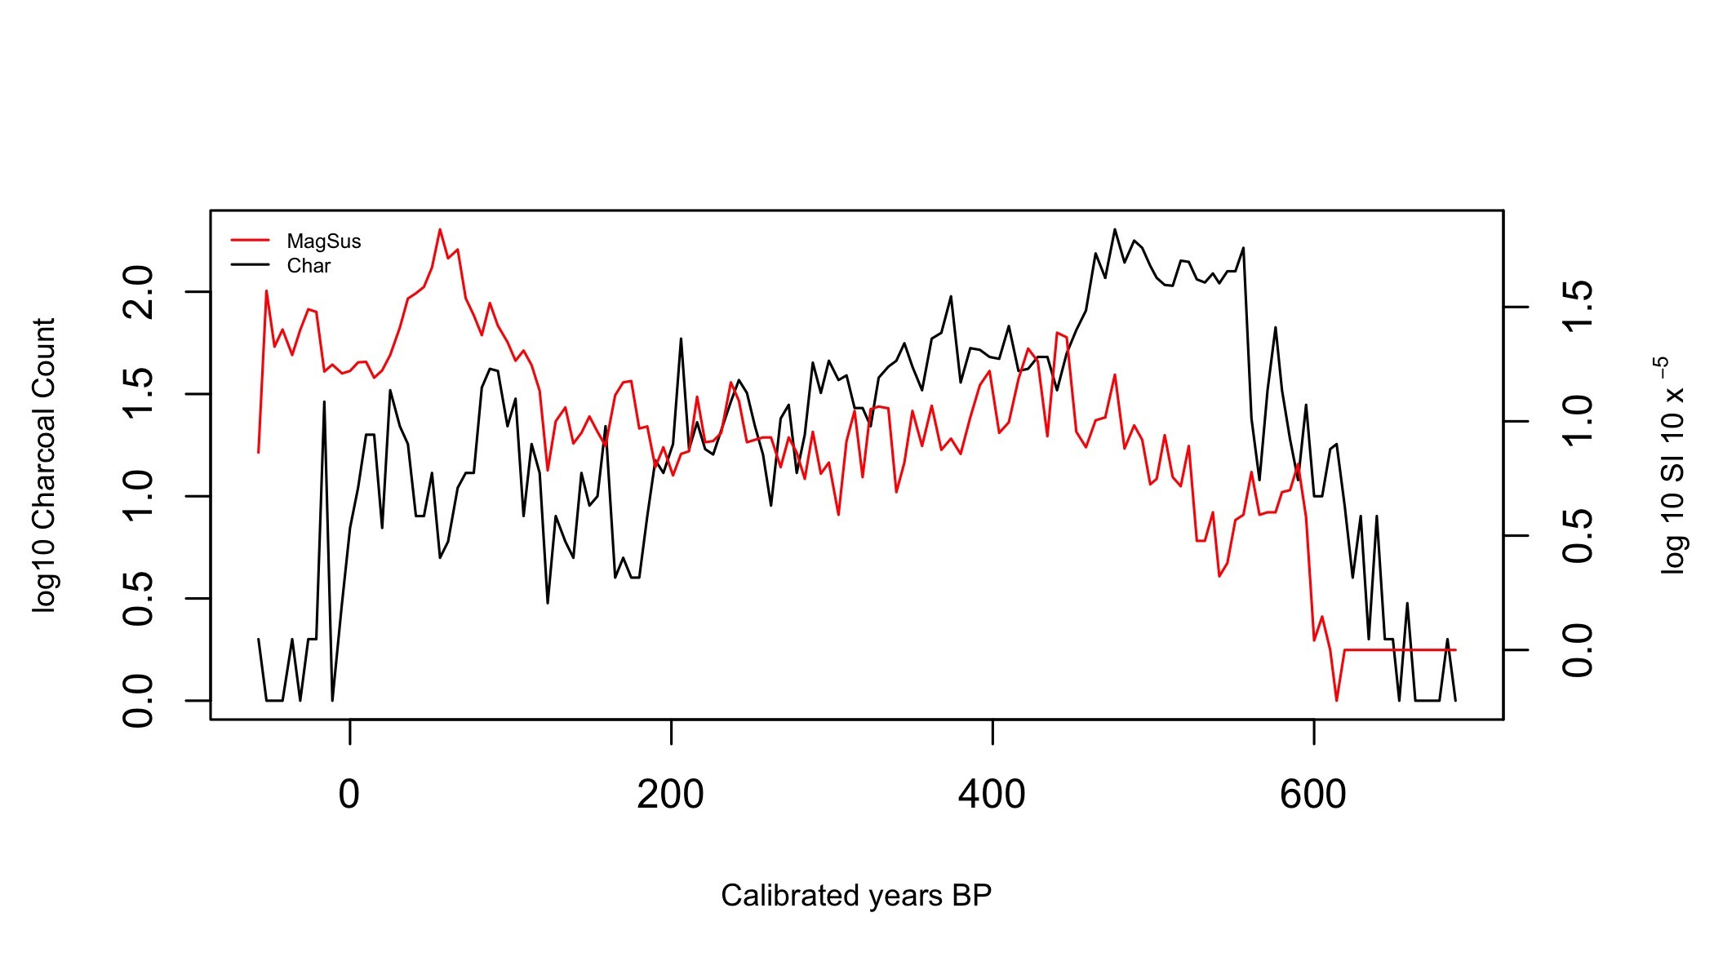

**Figure 9:** Magnetic susceptibility (log10) and charcoal particle count (log10) from the Seal Point core.

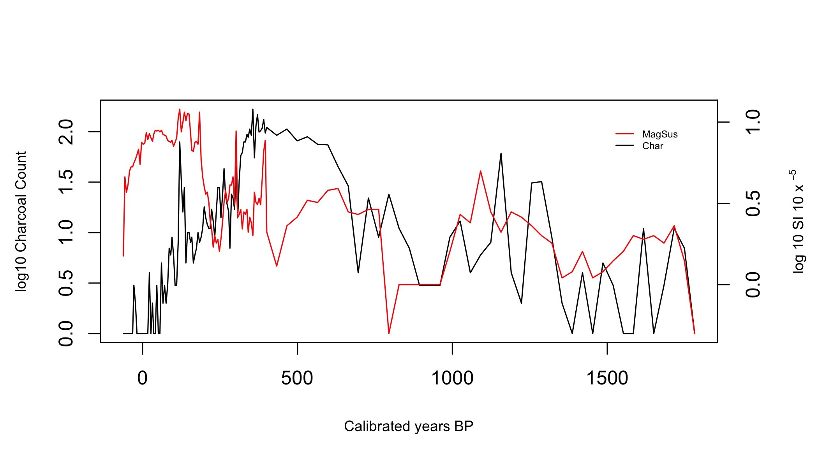

**Figure 10:** Magnetic susceptibility (log10) and charcoal particle count (log10) from the Ohana core.

264

vi. Definition of settlement and prehuman zones using all proxies

265

266

267

268

269

270

Previous work by Wilmshurst et al. (2008) places Polynesian settlement of New Zealand at c. 1280

AD. Based on the combination of sustained burning, decline of forest (Fig: 4) and increase in disturbance related taxa in the pollen record (Fig: 6), settlement of D’Urville Island likely began c.

650 cal years BP, corresponding to a depth of c. 64 cm in the Moawhitu Swamp core (Fig: 6). This

Polynesian settlement period represents zone 2 in the ordination presented (Fig:3), and shall be referred to as such hereafter; zone 1 will be identified as prehuman (Table: 1).

271

272

273

274

275

276

277

278

279

280

281

282

Exotic pollen taxa are a clear signal of European settlement and so their arrival c. 150 cal. years

BP make the European zone easier to identify. Pinus, non-native Plantago and Taraxacum appear at

20 cm in the Moawhitu Swamp core. Unfortunately, the lack of radiocarbon dates towards the top of all three cores, combined with the notorious difficulty in dating periods ranging from 1800 to 1950 AD (Hajdas, 2008) (a result of increases in fossil fuel combustion during the industrial revolution), creates a high degree of uncertainty in this zone. However, reliable records show permanent European settlement of D’Urville Island followed that of other New Zealand locations in 1840 AD, with the arrival of the first immigration ships at Port Hardy (a large inlet to the north of D’Urville Island) (Walls, 2009). Given these historical dates for European arrival, and the appearance of exotic taxa in the pollen reconstruction, it is safe to assume that European arrival occurred at around 20 cm (c. 150 cal. years BP), encompassing zone 3 (Fig: 3). The relevant depths, mean cal. years BP, zone numbers and subsequent names are given in Table 1.

**Table 1:** Zones identified as a result of age-depth model, pollen and charcoal analysis from all three cores.

|  |  |  |  |
| --- | --- | --- | --- |
| Depth (cm) | Mean estimate of cal. years BP | Zone Number | Zone Name |
| 0 - 20 cm | 0 - 150 | 3 | European |
| 20 - 64 cm | 150 - 650 | 2 | Polynesian |
| 64 - 250 cm | 650 - 2120 | 1 | Prehuman |

283

V. Discussion

284

285

Analysis of the data from the three sites considered in this study provide a first look at the late Holocence vegetation and fire history of D’Urville Island in the Marlborough Sounds, New

286

287

288

289

290

291

292

Zealand. Pollen assemblages, macroscopic and microscopic charcoal in the sediment profile from Moawhitu Swamp provide a 2200 year record of vegetation shifts and fire history. Cores taken from Seal Point and Ohana Lake date back to c. 688 and c. 1782 cal. years BP, respectively. This study confirms that fire was a rare event prior to human arrival on the island, but c. 650 cal. year BP, and coincident with human arrival, it dramatically increased. The introduction of exotic plant species following European arrival c. 150 cal. year BP further complicates an already highly

altered ecosystem.

293

i. What were the pre-human plant assemblages?

294

295

296

297

298

299

300

301

302

303

304

305

306

307

308

309

310

311

312

313

The lack of change in pollen percentages during the pre-human zone suggests relatively stable vegetation assemblages (Fig: 4). It is unlikely that large disturbance events on D’Urville Island occurred with any frequency prior to human settlement, although it has been suggested that a tsunami struck the island around the 16th century (Mitchell & Mitchell, 2007); however, there is no evidence in the pollen reconstruction for such an event. We see a clear and persistent dominance of Nothofagaceae throughout the pre-human period, on average accounting for over 50% of the total pollen sum (Fig: 4). During this pre-human period Nothofagaceae forest is associated with a tall emergent layer of podocarp species including Dacrydium cupressinum, Dacrycarpus dacrydioides, Prumnopitys ferruginea, Prumnopitys taxifolia and Podocarpus totara. This Nothofagaceae-Podocarpus forest would have been accompanied by a diverse canopy of Weinmannia spp., Nestegis spp. and Elaeocarpus spp. Smaller trees in the sub-canopy include Coprosma spp., Alectryon excelsus and Dodonaea viscosa. Climbers such as Rubus spp. also occur in the pollen record. Shrubs associated with forest margins including Aristotelia spp., Melicytus spp., Pseudopanax spp., Myrsine spp., Coprosma spp., Rubus spp., and bracken are consistent throughout. Dysoxylum spectabile, Aristotelia serrata, Rhopalostylis sapida and Leptospermum scoparium would have been abundant, likely on coastal slopes and gullies. Tree-ferns, namely Cyathea dealbata and Cyathea smithii, would have been present in both gully forest and the understory (Fig: 5). Low forest climax vegetation such as Pseudopanax spp, Metrosideros spp. and Dacrycarpus dacrydioides would have been far more prominent and likely not restricted to the higher elevations they are today. Rich palm and

Dysoxylum forest would have surrounded the lakes, wetlands and coastal areas.

314

315

316

Mistletoe are abundant throughout the pre-human phase, and although only identified to the family level, the species are likely Alepis flavida, Peraxilla colensoi and Peraxilla tetrapetala given their association with beech (Norton & de Lange, 1999). The historic abundance of mistletoes (up to

317

318

8% of total pollen sum, Fig: 5) can offer important baseline guidelines for restoration, given their

current threatened conservation status (Sweetapple et al., 2002).

319

ii. Pollen record after Polynesian settlement

320

321

322

323

324

325

326

327

328

329

330

331

332

333

334

335

The rise in sediment charcoal, combined with shifts in pollen taxa, clearly indicates human arrival at c. 650 cal years BP. Settlement brought increased fire frequencies on D’Urville Island, and with this there is a clear shift in both the dominant species and the nature of the plant assemblages. A common characteristic among the species that follow periods of increased fire activity is they are favoured in post-fire environments. The evidence provided here certainly follows that pattern, with bracken and grass abundance dramatically increasing, and subsequently persisting in the pollen reconstruction. Disturbance-related species also drive much of the differences observed between the pre-human and Polynesian zones (Fig: 6). Typha also increases substantially and comprises up to 15% of the pollen sum in some years (Fig: 6). This increase, in what is a nutrient-loving species, likely reflects an influx of detritus, sand and silt into both lake and swamp areas as a result of increased burning, and is a common response following deforestation in New Zealand wetlands (McGlone & Wilmshurst, 1999). An increase in sediment accumulation rates from Ohana support this hypothesis (Fig: 7). Typha pollen was also used by Maori to make cakes, with the roots providing a food source (Taylor, 2010), and deliberate action to support this practise could have contributed to its expansion. Magnetic susceptibility also increases during this period suggesting

inputs from erosion as a result of the loss of forest cover (Fig: 9, 10).

336

iii. Pollen record after European settlement

337

338

339

340

341

342

343

344

345

Forest taxa show little recovery during the European period, although beech does increase to around 15% of the pollen sum (Fig: 4). Beech is known to colonise small disturbed areas rapidly; however, its heavy seeds mean that it can be dispersal limited, recovering slowly without adequate seed sources (Wardle, 1984). On D’Urville Island this process is likely hampered by the rise of fire-adapted species such as Leptospermum scoparium, Kunzea spp., Pinus spp. and Cordyline spp. The emergence of Pinus in the pollen record is a familiar signal of European arrival. Pasture plants such as Trifolium spp. and exotic members of the Poaceae also appear. Pines were introduced to NZ early in the 20th century, and can be seen invading serpentine (ultramafic) areas on D’Urville. Bracken and grasses, limited before the introduction of fire, dominate the pollen record (Fig: 6)

346

and we see the arrival of other non-native taxa, including Taraxacum and Plantago.

347

iv. The charcoal record

348

349

350

351

352

353

354

355

356

357

358

359

360

361

The microscopic and macroscopic charcoal records reveal that fire was not a regular occurrence on D’Urville Island or the surrounding area until c. 650 cal. years BP. The macroscopic charcoal record shows a similar pattern, and, given the larger particle size, provides a better understanding of localised fire (Leys et al., 2013). The long absence of fire in this record is not surprising given: a) the relatively short period examined, and b) the evidence that fire events were often centuries apart in pre-human New Zealand (McGlone & Moar, 1998, McGlone & Wilmshurst, 1999, Ogden et al., 1998, Wardle, 2001). Interestingly there are some macroscopic peaks between 1288 and 1256 cal. years BP, and another at c. 1157 cal. years BP in the Ohana core (pre-human zone). In the Moawhitu Swamp core these peaks are just discernible in the microscopic charcoal record. These peaks are likely the result of small wetland fires, common in these environments and unlikely to have impacted the surrounding forest, a dynamic observed in wetland fires elsewhere (McGlone et al., 1984). The magnetic susceptibility signal also supports the presence of fire in the pre-human zone as we see a clear spike during this period (1288 and 1256 cal. years BP) (Fig: 10). Pollen

reconstruction from Ohana would allow further investigation of these fire events.

362

363

364

365

366

367

368

369

370

371

372

373

The 'Initial Burning Period' (IBP) in the decades immediately after Polynesian settlement (c. 1280

AD) was responsible for transforming large parts of the South Island’s native forests (McWethy et al., 2009), and was likely facilitated by positive feedbacks between fire and vegetation (Perry et al.,

2015). Given the limited amount of charcoal prior to this period, no evidence for dramatic climatic shifts (McWethy et al., 2009), we can assume the input of charcoal comes from anthropogenic fire on D’Urville Island, and follows a similar pattern of deliberate and systematic fires to those in other locations during the IBP. Fire was also an important part of Maori culture, used to remove scrub and forest(Stone & Langer, 2015). This process of burning also not only deprived wild game of cover, it aided in the growth of understory shrubs, particularly bracken, an important food source (Guild & Dudfield, 2009, McGlone et al., 2005). Fire also enabled the first settlers to clear land quickly for horticulture, and the cultivation of crops including ku¯ mara (Ipomoea batatas)

(Simmons, 1969).

374

375

Inferences beyond the timing of fires on D’Urville Island, as with any interpretation of paleo- charcoal, present challenges. Although we can be confident that fire most certainly occurred in the

376

377

378

379

380

381

382

383

384

385

386

387

388

389

390

region from 650 cal. years BP, it is difficult to determine the spatial patterns of this activity. It is likely that human populations were concentrated around argillite quarries (Walter et al., 2010). Burning would likely have commenced in the low land areas with easy access to water that were most suitable for settlement and horticulture. This is the pattern described in Perry et al. (2012) for New Zealand as a whole. The higher elevation areas would probably have been cleared later or accidentally burnt. The episodic nature of the charcoal records suggests temporal variation in fire events corresponding to anthropogenic activity; indeed, the small quantities of macroscopic charcoal earlier in the record indicates that the introduction of regular fire was rapid. Increases in charcoal deposition also correlate with increases in disturbance-related pollen taxa (Fig: 6) and the loss of forest taxa (Fig: 4). These factors, combined with D’Urville Island’s distance from the mainland (0.6 km), provide confidence that the macroscopic charcoal record demonstrates the onset of relatively large localised fires. It is important to acknowledge previous work that suggests macroscopic charcoal can travel several kilometres from its source during wildfires (Tinner et al.,

1998, 2006). Hence, there is the potential that macroscopic charcoal particles could come from

locations outside of D’Urville, but this is unlikely given the abundances seen.

391

392

393

394

395

396

397

398

399

400

401

402

403

Given the loss of closed canopy forest indicated in the pollen record (Fig: 4), it is likely that these post-settlement fire events were consistent re-burns of early successional vegetation rather than in previously unburned areas (Perry et al., 2014). The loss of woody material after the IBP would explain the decrease in macroscopic charcoal inputs, until a small spike occurred during the European period (Fig: 6, 7, 8). It is also likely that Polynesian interests in the islands were diminishing given intensive warfare and decreasing trade in argillite (Wellman, 1962). European settlement did not signal a respite for D’Urville Island, and the charcoal record demonstrates a continuation of burning, albeit somewhat subdued. The decrease in charcoal deposits are, in part, likely due to the adoption of different land clearing methods by European settlers (e.g. physical removal of scrub) and a decrease in fire-related land clearance methods. Despite the reduction in charcoal input, it appears that the beech-podocarp and coastal rich palm forest did not recover after the IBP, and that fire and land management practises continue to be a significant disturbance

mechanism.

404

v. Magnetic susceptibility

405

406

Soil magnetic susceptibility increases with the onset of the IBP but shows a consistent decline thereafter (Fig 9, 10). This trend is more prominent in the Seal Point record; although we do see

407

408

409

410

411

412

413

414

415

416

417

418

419

420

421

422

423

424

an increase in magnetic susceptibility at Ohana, it is less pronounced until some time after the IBP. Charcoal and magnetic susceptibility do not correlate well in either the Seal Point or Ohana records (r=0.179 and r=0.157, respectively, Fig: 9, 10). Interestingly we see the lowest correlations after Polynesian settlement and during the IBP (c. 550 - 420 cal. years BP), and after European settlement (c. 150 cal. years BP) (10). This lack of correlation indicates that an increase in charcoal deposits is not synchronous with changes in magnetic susceptibility. This pattern is supported by strengthened correlation in both Seal Point and Ohana (r=0.541 and r=0.547, respectively) when approximately 40-60 year time lags are applied to magnetic susceptibility, implying that changes in magnetic susceptibility are, at least in part, likely due to erosion events rather than magnetic enhancement of soils as a result of burning (i.e. the gradual degradation of forest slowly reducing soil cohesion and subsequently increasing input of allochthonous mineral material from erosion). Erosion is certainly well correlated with deforestation in New Zealand, with Wilmshurst (1997) noting significant erosion pulses in lake sediment cores as a result of deforestation during settlement in Lake Tutira, Hawke’s Bay area, North Island, New Zealand. McWethy et al. (2009) showed magnetic susceptibility was almost simultaneous with the onset of burning in some sites examined in the South Island, New Zealand, and its decline strongly associated with the end of the IBP. They suggest watershed vegetation was highly impacted, resulting in erosion events

almost immediately after fire.

425

426

427

428

429

430

431

432

433

434

We suggest that the time-lags observed in correlations between charcoal and magnetic susceptibility at D’Urville Island are, at least in part, due to a once abundant beech-podocarp forest being slowly degraded, with the associated deposition of allochthonous mineral increasing gradually over time rather than abruptly. The strengthened correlation after the IBP with a lag applied supports this hypothesis, suggesting that the process of burning removed riparian vegetation, and thus deposition rates increased. It can be argued that the gradual decline in magnetic susceptibility towards the end of the Polynesian and beginning of the European zone is due to the increased cover of bracken, known to stabilise soils after deforestation (McGlone et al., 2005, Wilmshurst,

1997). The stabilisation afforded by bracken is potentially site-specific, and hence we witness

different patterns in accumulation rates between Ohana and Seal Point (Fig: 7, 8).

435

vi. The consequences of human settlement

436

437

The removal of large quantities of forest, and the decline in species-rich palm and Dysoxylum forest leaves parts of D’Urville Island vulnerable to further disturbance events, and ongoing invasion by

438

439

440

441

442

443

444

445

446

447

448

449

450

451

452

the exotic species already established. The dominance of bracken and Poaceae in the pollen record, combined with the expansion of Leptospermum spp. and Pinus spp. is symbolic of a landscape that has been highly disturbed. Such sites can quickly become fire-prone amplifying a ‘fire begets fire’ feedback dynamic. Colonisation by later successional species is made increasingly difficult by the already limited remnant forest and respective seed sources remaining on D’Urville Island. This positive feedback is suggested by Perry et al. (2014); the post-vegetation landscape is more flammable, making the system more susceptible to fire, and hence harder for later succession species to establish. Gorse (Ulex europaeus), although not present in the pollen record but prevalent on D’Urville Island, will contribute to the fire-prone nature of early successional locations given the high ignitability of its litter (Madrigal et al., 2012); it was the most flammable, at the shoot-level, of the 60 species assessed by Wyse et al. (2016). Further disturbance events, be they fire or other natural occurrences such as drought, will result in the colonisation of species well-adapted to disturbed environments. Feedbacks between disturbance and invasive plant taxa can potentially result in broad areas of homogeneous early successional vegetation that reduce the potential of

native flora to establish (Gaertner et al., 2014).

453

454

455

456

457

458

459

460

461

462

463

464

465

The 'fire begets fire' pattern is shown by the transition from an old landscape, dominated by the species prominent in the pre-human period, to a young, fire prone system comprised of other species that established in the late Polynesian/early European period on D’Urville Island. Although fire activity has certainly decreased in recent years, the dominant vegetation that remains will be highly susceptible to natural, or accidental fire events. Seedling establishment in these early-successional environments is likely further hampered by browsing from rats (Rattus rattus) present on D’Urville Island (Wilson et al., 2003). Breaking this cycle is extremely difficult as the system could be characterised as having shifted to an alternative stable state reinforced by strong positive feedbacks (Bowman et al., 2015). These systems then exhibit a difficult to reverse shift in both vegetation structure and composition (Perry et al., 2014). Such multi-stressed environments increase the complications for restoration as a result of non-independent pressures, requiring each stressor to be addressed simultaneously in order to reduce the potential for arrested succession

(Perry et al., 2015).

466

vii. Implications for restoration

467

468

Offshore islands in New Zealand have benefited from extensive research into best management and restoration practises (e.g. Buxton et al., 2014, Parker & Laurence, 2008, Russell & Broome,

469

470

471

472

473

474

475

476

477

478

479

480

481

482

483

484

2016, Simberloff, 2002, Towns et al., 2013, Towns & Broome, 2003). One key ingredient in these previous projects has been the eradication of pests and invasive weeds, made easier by the uninhabited status of these islands. Glen et al. (2013) argue that it is perhaps time we look beyond uninhabited islands and towards those with a permanent population when considering multi- species eradication efforts. Given the complexities in such projects this is certainly ambitious, and would require the full engagement of local communities (Ogden & Gilbert, 2009). D’Urville Island would be an extremely interesting case-study for such an experiment, and potentially propel it to the forefront of conservation/restoration projects worldwide. The island posseses many areas worthy of conservation, given the number of threatened mistletoe, ultramafic communities and regionally rare species. Complete eradication of pests and invasive weeds is perhaps too ambitious, but the island presents an excellent opportunity for future forest and wetland restoration. A major challenge stems from the potential for arrested succession in the pyrophyllic exotic/Leptospermum scoparium/Kunzea ericoides dominated areas of D’Urville Island, for which the adequate control of fire will be required. Further intervention in the form of restorative plantings can aid in the regeneration of closed forest and move these systems further away from their fire prone status.

The vegetation baselines that are presented here can inform such restoration efforts.

485

486

487

488

489

490

491

492

Pollen and charcoal records such as those presented provide an opportunity to inform restoration effort, and aid in the provision of pre-human vegetation baselines. Such information about pre-settlement plant assemblages can help managers in determining the viability of, for example, the reintroduction of species formally present (Wilmshurst et al., 2014). Simulation models as per Perry et al. (2016) can assist in further exploring succession dynamics (i.e. fire begets fire patterns) resulting from increases in fire frequency. These records form the building blocks of such exploration, and will aid us in the construction of modelling tools to resolve some of the

questions we have posed.

493

References

494

495

Anderson, M. J. (2001). A new method for non-parametric multivariate analysis of variance.

Austral Ecology, 26(1), 32–46.

496

497

Anderson, S. A., Doherty, J. J., & Pearce, H. G. (2008). Wildfires in New Zealand from 1991 to 2007.

New Zealand Journal of Forestry, 53(3), 19–22.

498

499

Beever, R., Brownsey, P., & Bellingham, R. (1989). New records of vascular plants from D’Urville

Island, Marlborough Sounds. Wellington Botanical Society Bulletin, (45), 116–118.

500

501

Bowman, D. M., Perry, G. L., & Marston, J. (2015). Feedbacks and landscape-level vegetation

dynamics. Trends in Ecology and Evolution, 30(5), 255–260.

502

503

Buxton, R. T., Jones, C., Moller, H., & Towns, D. R. (2014). Drivers of seabird population recovery

on New Zealand islands after predator eradication. Conservation Biology, 28(2), 333–344.

504

505

Dixon, P. & Palmer, M. (2003). VEGAN, a package of R functions for community ecology. Journal

of Vegetation Science, 14(6), 927–930.

506

507

Ewers, R. M., Kliskey, A. D., Walker, S., Rutledge, D., Harding, J. S., & Didham, R. K. (2006). Past

and future trajectories of forest loss in New Zealand. Biological Conservation, 133(3), 312–325.

508

509

Faith, D. P., Minchin, P. R., & Belbin, L. (1987). Compositional dissimilarity as a robust measure of

ecological distance. Vegetation, 69(1-3), 57–68.

510

511

512

Gaertner, M., Biggs, R., Te Beest, M., Hui, C., Molofsky, J., & Richardson, D. M. (2014). Inva- sive plants as drivers of regime shifts: identifying high-priority invaders that alter feedback

relationships. Diversity and Distributions, 20(7), 733–744.

513

514

515

Glen, A. S., Atkinson, R., Campbell, K. J., Hagen, E., Holmes, N. D., Keitt, B. S., Parkes, J. P., Saunders, A., Sawyer, J., & Torres, H. (2013). Eradicating multiple invasive species on inhabited

islands: the next big step in island restoration? Biological Invasions, 15(12), 2589–2603.

516

517

Guild, D. & Dudfield, M. (2009). A history of fire in the forest and rural landscape in New Zealand:

part 1, pre-Maori and pre-European influences. New Zealand Journal of Forestry, 54(1), 34–38.

518

519

Hajdas, I. (2008). Radiocarbon dating and its applications in Quaternary studies. Quaternary

Science, 57(2), 24.

520

521

Harris, J. A., Hobbs, R. J., Higgs, E., & Aronson, J. (2006). Ecological restoration and global climate

change. Restoration Ecology, 14(2), 170–176.

522

523

Haslett, J. & Parnell, A. (2008). A simple monotone process with application to radiocarbon-dated

depth chronologies. Applied Statistics, 57(4), 399–418.

524

525

526

Hogg, A. G., Hua, Q., Blackwell, P. G., Niu, M., Buck, C. E., Guilderson, T. P., Heaton, T. J., Palmer, J. G., Reimer, P. J., Reimer, R. W., et al. (2013). SHCal13 Southern Hemisphere calibration,

0–50,000 years cal BP. Radiocarbon, 55(2), 1–15.

527

528

529

530

Horrocks, M., Deng, Y., Ogden, J., Alloway, B., Nichol, S., & Sutton, D. (2001). High spatial resolution of pollen and charcoal in relation to the c. 600 year BP Kaharoa Tephra: Implications for Polynesian settlement of Great Barrier Island, northern New Zealand. Journal of Archaeological

Science, 28(2), 153–168.

531

532

Juggins, S. (2007). Software for ecological and palaeoecological data analysis and visualisation. Newcastle

University, Newcastle upon Tyne, UK.

533

Juggins, S. (2015). rioja: Analysis of Quaternary Science Data. R package version 0.9-9.

534

535

Keeley, J. E., Pausas, J. G., Rundel, P. W., Bond, W. J., & Bradstock, R. A. (2011). Fire as an

evolutionary pressure shaping plant traits. Trends in Plant Science, 16(8), 406–411.

536

537

538

539

Kitzberger, T., Perry, G., Paritsis, J., Gowda, J., Tepley, A., Holz, A., & Veblen, T. T. (2016). Fire–vegetation feedbacks and alternative states: common mechanisms of temperate forest vulnerability to fire in southern South America and New Zealand. New Zealand Journal of Botany,

54(2), 247–272.

540

541

Lee, W. (1992). New Zealand ultramafics. In B. Roberts (Ed.), The Ecology of Areas with Serpentinized

Rocks (pp. 375–417). Springer, Dordrecht.

542

543

544

Leys, B., Carcaillet, C., Dezileau, L., Ali, A. A., & Bradshaw, R. H. (2013). A comparison of charcoal measurements for reconstruction of Mediterranean paleo-fire frequency in the mountains of

Corsica. Quaternary Research, 79(3), 337–349.

545

546

547

Madrigal, J., Marino, E., Guijarro, M., Hernando, C., & Díez, C. (2012). Evaluation of the flammability of gorse (Ulex europaeus L.) managed by prescribed burning. Annals of Forest Science,

69(3), 387–397.

548

549

McGlone, M. (1983). Polynesian deforestation of New Zealand: a preliminary synthesis. Archaeology

in Oceania, 18(1), 11–25.

550

551

552

McGlone, M. & Walker, S. (2011). Potential effects of climate change on New Zealand’s terrestrial biodiversity and policy recommendations for mitigation, adaptation and research. Science for

Conservation, (312).

553

554

McGlone, M. S. (2009). Postglacial history of New Zealand wetlands and implications for their conservation. New Zealand Journal of Ecology, 33(1), 1–23.

555

556

557

McGlone, M. S., Kershaw, A. P., & Markgraf, V. (1992). El niño/southern oscillation climatic variability in australasian and south american paleoenvironmental records. El Niño: Historical

and paleoclimatic aspects of the Southern Oscillation, 435–462.

558

559

McGlone, M. S. & Moar, N. T. (1998). Dryland Holocene vegetation history, Central Otago and the

Mackenzie Basin, South Island, New Zealand. New Zealand Journal of Botany, 36(1), 91–111.

560

561

562

McGlone, M. S., Nelson, C. S., & Todd, A. J. (1984). Vegetation history and environmental significance of pre-peat and surficial peat deposits at Ohinewai, Lower Waikato lowland. Journal

of the Royal Society of New Zealand, 14(3), 233–244.

563

564

McGlone, M. S. & Wilmshurst, J. M. (1999). Dating initial Maori environmental impact in New

Zealand. Quaternary International, 59(1), 5–16.

565

566

567

McGlone, M. S., Wilmshurst, J. M., & Leach, H. M. (2005). An ecological and historical review of bracken (Pteridium esculentum) in New Zealand, and its cultural significance. New Zealand

Journal of Ecology, 29(2), 165–184.

568

569

570

571

McWethy, D. B., Higuera, P. E., Whitlock, C., Veblen, T. T., Bowman, D. M. J. S., Cary, G. J., Haberle, S. G., Keane, R. E., Maxwell, B. D., Mcglone, M. S., Perry, G. L. W., Wilmshurst, J. M., Holz, A.,

& Tepley, A. J. (2013). A conceptual framework for predicting temperate ecosystem sensitivity

to human impacts on fire regimes. Global Ecology and Biogeography, 22(8), 900–912.

572

573

McWethy, D. B., Whitlock, C., Wilmshurst, J. M., McGlone, M. S., & Li, X. (2009). Rapid deforesta-

tion of South Island, New Zealand, by early Polynesian fires. The Holocene, 19(6), 883–897.

574

575

576

McWethy, D. B., Wilmshurst, J. M., Whitlock, C., Wood, J. R., & McGlone, M. S. (2014). A high- resolution chronology of rapid forest transitions following Polynesian arrival in New Zealand.

PloS One, 9(11), 111328.

577

578

Mitchell, H. & Mitchell, M. J. (2007). History of Maori of Nelson and Marlborough, volume 2. Huia

Publishers.

579

Moar, N. T. (1993). Pollen grains of New Zealand Dicotyledonous Plants. Manaaki Whenua Press.

580

Moore, P. D., Webb, J. A., & Collison, M. E. (1991). Pollen analysis. Blackwell scientific publications.

581

NIWA (2017). CliFlo: NIWA’s National Climate Database on the Web. [http://cliflo.niwa.co.nz/.](http://cliflo.niwa.co.nz/)

582

583

Norton, D. & de Lange, P. (1999). Host specificity in parasitic mistletoes (Loranthaceae) in New

Zealand. Functional Ecology, 13(4), 552–559.

584

585

Ogden, J., Basher, L. E. S., & McGlone, M. (1998). Fire, forest regeneration and links with early

Human habitation: Evidence from New Zealand. Annals of Botany, 81(6), 687–696.

586

587

588

Ogden, J. & Gilbert, J. (2009). Prospects for the eradication of rats from a large inhabited island:

community based ecosystem studies on Great Barrier Island, New Zealand. Biological Invasions,

11(7), 1705–1717.

589

590

591

Oksanen, J., Blanchet, F. G., Kindt, R., Legendre, P., Minchin, P. R., O’Hara, R. B., Simpson, G. L., Solymos, P., Stevens, M. H. H., & Wagner, H. (2016). vegan: Community ecology package. R

package version 2.3-4.

592

593

Parker, K. A. & Laurence, J. (2008). Translocation of North Island saddleback Philesturnus rufusater

from Tiritiri Matangi Island to Motuihe Island, New Zealand. Conservation Evidence, 5, 47–50.

594

595

Parnell, A. (2014). Bchron: Radiocarbon dating, age-depth modelling, relative sea level rate

estimation, and non-parametric phase modelling. R package version, 4(1).

596

597

Pawson & Brooking (2002). Environmental Histories of New Zealand. Melbourne Oxford University

Press.

598

599

600

Perry, G. L. W., Wainwright, J., Etherington, T. R., & Wilmshurst, J. M. (2016). Experimental

Simulation : Using Generative Modeling and Palaeoecological Data to Understand Human- Environment Interactions. 4(109), 1–14.

601

602

Perry, G. L. W., Wilmshurst, J. M., & McGlone, M. S. (2014). Ecology and long-term history of fire

in New Zealand. New Zealand Journal of Ecology, 38(2), 157–176.

603

604

605

Perry, G. L. W., Wilmshurst, J. M., McGlone, M. S., McWethy, D. B., & Whitlock, C. (2012). Explaining fire-driven landscape transformation during the Initial Burning Period of New

Zealand’s prehistory. Global Change Biology, 18(5), 1609–1621.

606

607

608

Perry, G. L. W., Wilmshurst, J. M., McGlone, M. S., & Napier, A. (2012). Reconstructing spatial vulnerability to forest loss by fire in pre-historic New Zealand. Global Ecology and Biogeography,

21(10), 1029–1041.

609

610

611

Perry, G. L. W., Wilmshurst, J. M., Ogden, J., & Enright, N. J. (2015). Exotic mammals and invasive plants alter fire-related thresholds in southern temperate forested landscapes. Ecosystems, 18(7),

1290–1305.

612

613

R Core Team (2015). R: A Language and Environment for Statistical Computing. Vienna, Austria: R Foundation for Statistical Computing.

614

615

616

617

Richardson, S. J., Laughlin, D. C., Lawes, M. J., Holdaway, R. J., Wilmshurst, J. M., Wright, M., Curran, T. J., Bellingham, P. J., & McGlone, M. S. (2015). Functional and environmental determinants of bark thickness in fire-free temperate rain forest communities. American Journal

of Botany, 102(10), 1590–1598.

618

619

Rogers, G. M., Walker, S., Basher, L. M., & Lee, W. G. (2007). Frequency and impact of Holocene

fire in eastern South Island, New Zealand. New Zealand Journal of Ecology, 31(2), 129–142.

620

621

Russell, J. C. & Broome, K. G. (2016). Fifty years of rodent eradications in New Zealand: another

decade of advances. New Zealand Journal of Ecology, 40(2), 197–204.

622

Salmon, J. T. (1975). Biogeography and Ecology in New Zealand. Springer, Netherlands.

623

624

Simberloff, D. (2002). Turning the Tide: The Eradication of Invasive Species. IUCN SSC Invasive

Species Specialist Group. IUCN Gland, Switzerland and Cambridge, UK.

625

626

Simmons, D. (1969). Economic change in New Zealand prehistory. The Journal of the Polynesian

Society, 78(1), 3–34.

627

628

Stone, G. & Langer, E. (2015). Te ahi i te ao MÄA˛ori: MÄA˛ori use of fire: Traditional use of fire to

inform current and future fire management in New Zealand. MAI, 4(1), 15–28.

629

630

Sullivan, J. J., Kelly, D., & Ladley, J. J. (2010). Feathers to fur: the status of New Zealand ecological

research in 2009. New Zealand Journal of Ecology, 34(1), 1.

631

632

633

Sweetapple, P., Nugent, G., Whitford, J., & Knightbridge, P. (2002). Mistletoe (Tupeia antarctica)

recovery and decline following possum control in a New Zealand forest. New Zealand Journal of

Ecology, 26(1), 61–71.

634

635

636

Taylor, R. (2010). Te Ika a Maui: Or, New Zealand and its inhabitants, illustrating the origin, manners, customs, mythology, religion, rites, songs, proverbs, fables, and language of the natives. Cambridge

University Press.

637

638

639

Tinner, W., Conedera, M., Ammann, B., Gaggeler, H. W., Gedye, S., Jones, R., & Sagesser, B. (1998). Pollen and charcoal in lake sediments compared with historically documented forest fires in

southern Switzerland since AD 1920. The Holocene, 8(1), 31–42.

640

641

642

Tinner, W., Hofstetter, S., Zeugin, F., Conedera, M., Wohlgemuth, T., Zimmermann, L., & Zweifel, R. (2006). Long-distance transport of macroscopic charcoal by an intensive crown fire in the Swiss Alps: Implications for fire history reconstruction. The Holocene, 16(2), 287–292.

643

644

645

Towns, D., West, C., & Broome, K. (2013). Purposes, outcomes and challenges of eradicating invasive mammals from New Zealand islands: an historical perspective. Wildlife Research, 40(2),

94–107.

646

647

Towns, D. R. & Broome, K. G. (2003). From small Maria to massive Campbell: forty years of rat

eradications from New Zealand islands. New Zealand Journal of Zoology, 30(4), 377–398.

648

Walls, G. (2005). D’Urville Island and its islets, an ecological overview. Techincal Report.

649

Walls, G. (2009). D’Urville Ecological District. Technical Report.

650

651

Walter, R., Jacomb, C., & Bowron-Muth, S. (2010). Colonisation, mobility and exchange in New

Zealand prehistory. Antiquity, 84(324), 497–513.

652

653

Wardle, J. (1984). The New Zealand Beeches. Ecology, utilisation, and management. Wellington: New

Zealand Forest Service.

654

655

Wardle, P. (2001). Holocene forest fires in the upper Clutha district, Otago, New Zealand. New

Zealand Journal of Botany, 39(3), 523–542.

656

657

Wellman, H. W. (1962). Maori occupation layers at D’Urville Island, New Zealand. New Zealand

Journal of Geology and Geophysics, 5, 55–73.

658

659

Whitlock, C. & Larsen, C. (2002). Charcoal as a fire proxy. In Tracking environmental change using

lake sediments (pp. 75–97). Springer.

660

661

Wilmshurst, J. M. (1997). The impact of human settlement on vegetation and soil stability in

Hawke’s Bay, New Zealand. New Zealand Journal of Botany, 35(1), 97–111.

662

663

664

Wilmshurst, J. M., Anderson, A. J., Higham, T. F. G., & Worthy, T. H. (2008). Dating the late prehistoric dispersal of Polynesians to New Zealand using the commensal Pacific rat. Proceedings

of the National Academy of Sciences, 105(22), 7676–80.

665

666

667

Wilmshurst, J. M., Higham, T. F., Allen, H., Johns, D., & Phillips, C. (2004). Early Maori settlement impacts in northern coastal Taranaki, New Zealand. New Zealand Journal of Ecology, 28(2),

167–179.

668

669

Wilmshurst, J. M. & McGlone, M. S. (1996). Forest disturbance in the central North Island, New

Zealand, following the 1850 BP Taupo eruption. The Holocene, 6(4), 399–411.

670

671

672

Wilmshurst, J. M., Moar, N. T., Wood, J. R., Bellingham, P. J., Findlater, A. M., Robinson, J. J., & Stone, C. (2014). Use of pollen and ancient DNA as conservation baselines for offshore islands

in New Zealand. Conservation Biology, 28(1), 202–212.

673

674

675

Wilson, D. J., Lee, W. G., Webster, R. A., & Allen, R. B. (2003). Effects of possums and rats on seedling establishment at two forest sites in New Zealand. New Zealand Journal of Ecology, 27(2),

147–155.

676

677

678

679

Wyse, S. V., Perry, G. L. W., O’Connell, D. M., Holland, P. S., Wright, M. J., Hosted, C. L., Whitelock, S. L., Geary, I. J., Maurin, K. J., & Curran, T. J. (2016). A quantitative assessment of shoot flammability for 60 tree and shrub species supports rankings based on expert opinion.

International Journal of Wildland Fire, 25(4), 466–477.

680

681

Zavaleta, E. S. & Heller, N. E. (2009). Biodiversity management in the face of climate change: A

review of 22 years of recommendations. Biological Conservation, 142(1), 14–32.